We analyzed covid_clean_3_no_missing_values using the InfoGainAttributeEval technique, which uses a Ranker search method. The result is shown below.

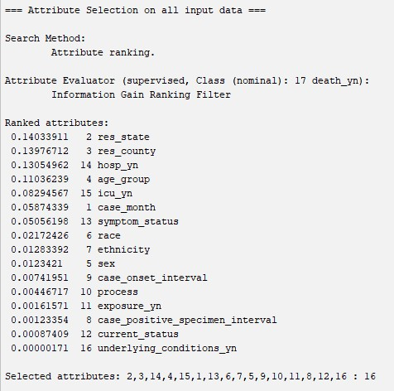

Using a fairly arbitrary cutoff of 0.1, we drop every attribute below (and including) icu_yn. This leaves us with just res_state, res_county, hosp_yn, and age_group. The resulting dataset is saved as covid_InfoGainAttributeEval.